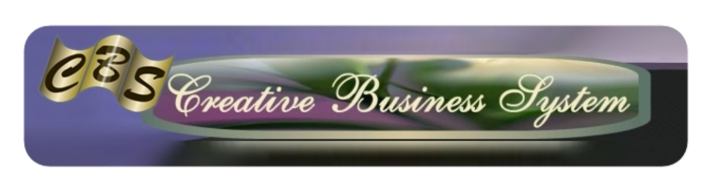

Terms of Agreement for use of Creative Business System Tutorials

All of Creative Business System's tutorials including videos and written content shall reside on a private, dedicated server under an encrypted and password protected log-in and are copyrighted by Creative Business System as intellectual property. You may not copy, post, reproduce, redistribute or sell this content in any form.
Access to these materials is exclusive only to authorized persons who accept the terms of this agreement. Your access and usage under this agreement will terminate automatically and without notice if you fail to comply with any of the terms.
This intellectual property will also be protected by periodic password resets where-in only authorized users will be issued updated log-in credentials.
Your signature below indicates your compliance with the terms of this agreement.

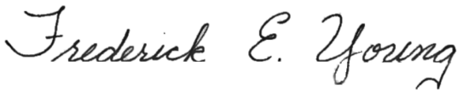
FREDERICK E. YOUNG
_____________________________

PRINT YOUR NAME HERE
___________________________

____________________________
Sign Your Name Here

